SCHOOLS SPORTS VICTORIA

DIVISION

CROSS COUNTRY CHAMPIONSHIPS 2023

Thursday 1st June 2023

Bundoora Park, 1069 Plenty Rd, Bundoora, Vic 3083

PROGRAM

*9.45 Officials report*

9.45

All competitors to be assembled in District areas

10.00 Marshall Darebin Boys and Nillumbik Girls 9/10 Years

10.10 Darebin Boys/ Nillumbik Girls 9/10 Years 2000 metres

10.20 Marshall Darebin Girls / Nillumbik Boys 9/10 Years

10.30 Darebin Girls / Nillumbik Boys 9/10 Years 2000 metres

10.45 Marshall Darebin Boys/ Nillumbik Girls 11 Years

10.55 Darebin Boys/ Nillumbik Girls 11 Years 3000 metres

11.05 Marshall Darebin Girls / Nillumbik Boys 11 Years

11.15 Darebin Girls / Nillumbik Boys 11 Years 3000 metres

11.30 Marshall Darebin Boys / Nillumbik Girls 12/13 Years

11.40 Darebin Boys / Nillumbik Girls12/13 Years 3000 metres

11.50 Marshall Darebin Girls / Nillumbik Boys 12/13 Years

12.00 Darebin Girls / Nillumbik Boys 12/13 Years 3000 metres

S.S.V. Northern Metropolitan Region Championships

Wednesday 14th of June 1pm – 3:00pm

Kilmore Racing Club

SCHOOLS SPORT VICTORIA

DIVISION

CROSS COUNTRY CHAMPIONSHIPS 2023

**Course Map**

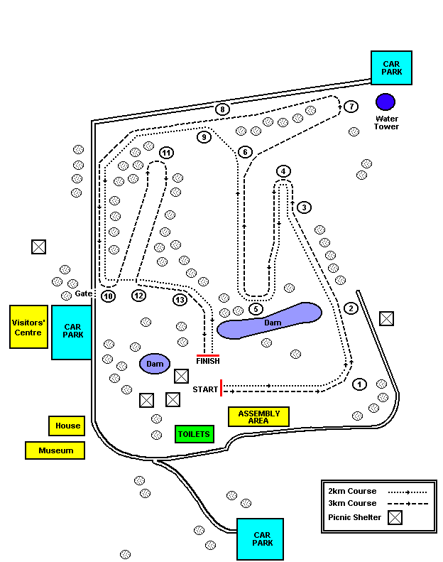

**Marshalling** Commences at 10.00am. No event will start before the advertised marshalling time.

No spikes, football boots, hockey shoes or other cleated shoes are permitted.

**Outside assistance (pacing) by a person not competing in the race is not permitted.**